Interesting Deals - a feature in aaBridge
Written by Roger Pfister roger@RogerPf.com http://RogerPf.com/aaBridge
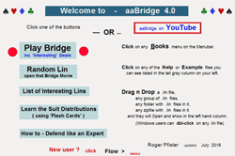
On the aaBridge opening Welcome page is the large Play Bridge button -- here marked by the two large red dots.

Click on the Play Bridge button to open the Play Bridge window
On the left hand side in the lower corner is the New Deal button.
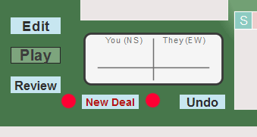
Click the New Deal button ...
(again marked by the two large red dots).
this will show you a new deal, bid the hand for you, and then make the lead for West.
(You can switch off the bidding display – see later)
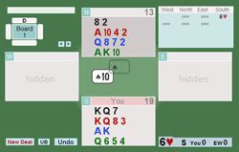
You play the cards by clicking on a card in dummy's hand or your hand (South).

<continued on next page>
On the right hand side of the Play Bridge window is a column showing the New Deals options. You can stop the display of the bidding with the Bidding – watch option (single red dot).
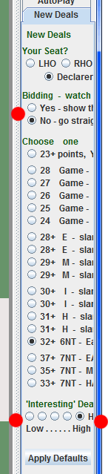
Below that is the Choose one option which is the main selector for the type and shape of hand that you would like aaBridge to deal for you. The image on the right shows 32+ 6NT - ... as selected.
( Suggestion try a different setting e.g. 31+ slam 4-4, 4-3 )
Below that is the 'Interesting' Deal Selector option, (shown by the two red dots).
There are 5 possible settings. When you click the New Deal button aaBridge will deal many hands and after rejecting those that do not match the shape and point count you have selected, it will (depending on your selection) try to remove hands it regards and less interesting.
The right most option rejects the most hands.

How to Use (just a couple of suggestions)
If you are a new player and think you suffer from "big-hand-itis" just play these deals until you get bored, that way "big hands" that occur at the table will not be such a shock.
If you want to Practice your Planning – I suggest you stop after the first lead and take your time. This does require great discipline. It is so EASY to just start playing and not to practice planning as you should.
<end document>

